SUMMARY REPORT

Skill Enhancement Program for Prospective Women Entrepreneurs

ARC Building, University of Delhi I 11-16 October, 2016
FOREWORD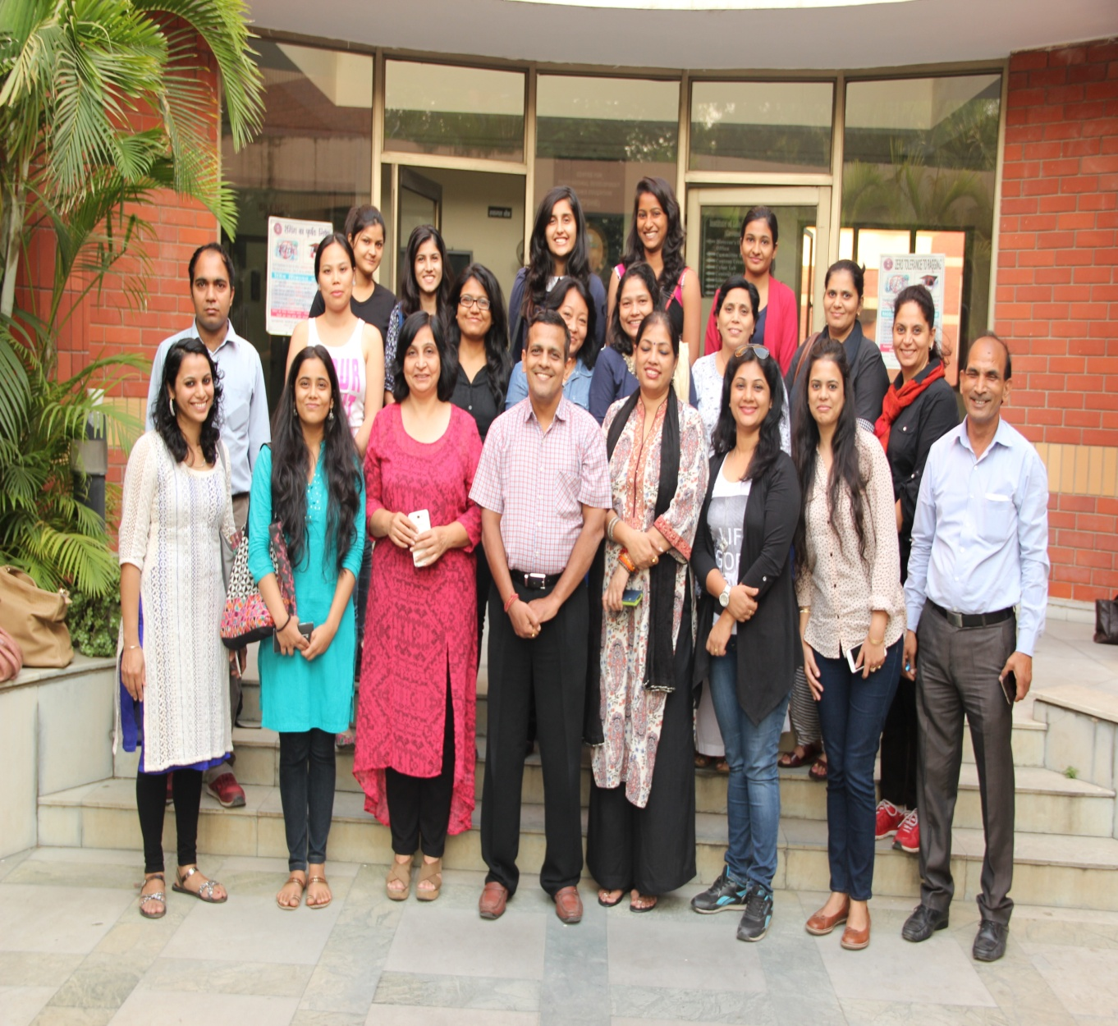

CIC- CENTRE FOR SCIENCE EDUCATION AND COMMUNICATION
Skill Enhancement Program for Prospective Women Entrepreneurs
11-16 October 2016

Day | Speaker | Title
11 October 2016 | Anshumali Saxena | Introduction to Innovation and Entrepreneurship, Research Mindset and Nurturing Innovative ideas
 | Pranay Chowdhary | Entrepreneur Success Story
12 October 2016 | Bipin Shah | Entrepreneurship - A career option and the process of New Enterprise Creation  Government Policies and Incentives for Women Entrepreneurs and Legalization of Venture Creation
 | Asome | Entrepreneurial Mindset. Motivations, and Behaviors
 | Renuka Dudeja | Entrepreneur Success Story
13 October | Kawal Gill | Industry Understanding
 | Anchal Bhatia | Societal Empowerment & Social Innovation
 | Nancy Juneja | Customer Understanding
14 October 2016 | Kamna Hazrati | Innovation Strategies for Competitive Advantage
 | Thaldev | Successfully Bringing Innovations to Market
 | Aditi Veena | Entrepreneur Success Story
15 October 2016 | Anshumali Saxena | The Internet as a Selling Platform
 | Monika Mudhgal | Team Building
 | Aditya Sakhuja | Entrepreneur Success Story
16 October 2016 | Amit Mohopatra | Business Modeling
 | Balwan Bansal | Securing Finances

INTRODUCTION AND BACKGROUND

Introduction

Background to CIC – Centre for Science Education and Communication

SESSIONS

DAY ONE – TUESDAY – 11 OCTOBER, 2016

Session 1: Introduction to Innovation & Entrepreneurship, Research Mindset and Nurturing Innovative Ideas
Objective: Understanding becoming an entrepreneur, knowing the qualities of an entrepreneur and being a successful entrepreneur.
Speaker: Anshumali Saxena
Key Themes:
- Characteristics of an entrepreneur
- Entrepreneurship Process
- Looking out for opportunities
- Creativity and Innovation
- Never giving up

Session 2: Success Story
Objective:
Speaker: Pranay Chowdhary, founder & CEO, Actozen
Key Themes:

DAY 2 – WEDNESDAY – 12 OCTOBER, 2016

Session 1: Entrepreneurship: A career option and the process of new Enterprise Creation ; Government policies and Incentives for Women Entrepreneurs and legalization of Venture Creation
Objective: To discover the traits of an entrepreneur , to know what it takes to be an entrepreneur and how to set up a business with the help of financials aids provided by the government and other financial institutions.
Speaker: Bipin Shah
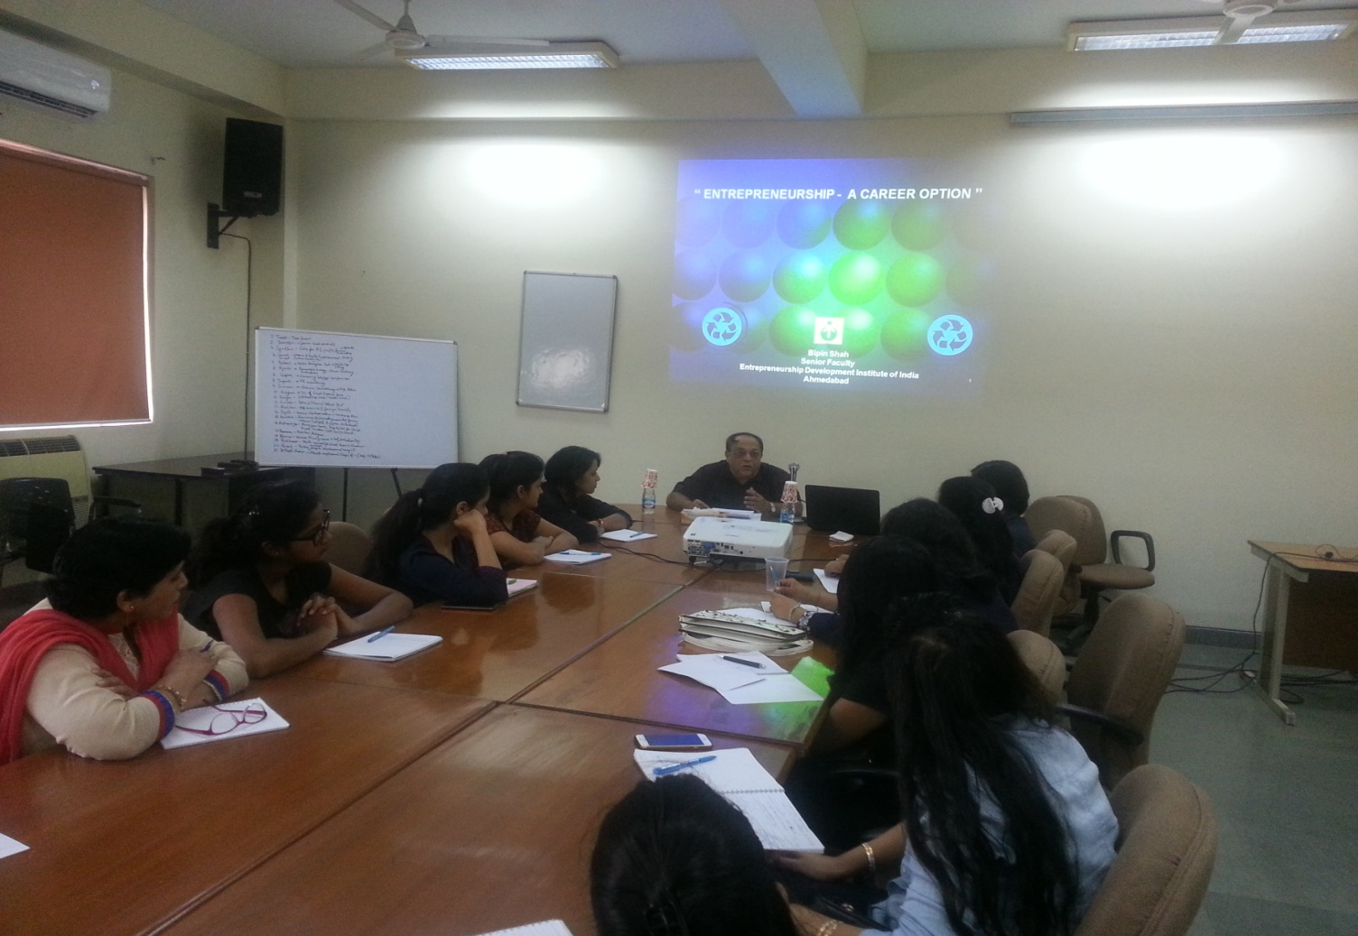
Bipin Shah
B.Sc.(Chem.); MBA (Finance) A business management specialist with 42 years of experience in consultancy and industry in the areas of project formulation and appraisal, project planning and enterprise establishment, and management. Has been Managing Director of Gujarat Industrial & Technical Consultancy Organisation Ltd. and Member of the Governing Council of CDC, Ministry of S&T, GoI. Also worked as President for 6 years in Chemicals and Pharmaceutical Companies. He is on Experts' panel of UNIDO, UNDP & EXIM Bank of India. Specialises in plastic industry and has exposure in chemical and pharma sector MSMEs
Key Themes:
- “The highest reward for a person’s toil is not what they get for it but what they become by it.”- John Ruskin
- Entrepreneurship is a continuous journey, a journey in which an entrepreneur has to face all the challenges and is expected to identify and fill the gap.
- Traits of an entrepreneur – Risk taking ability, vision, Innovativeness.
- Entrepreneurial competencies.
- It’s not easy to build an enterprise but if one is determined, can do the wonders. New enterprise creation process.
- The manager is chosen by his mental abilities and qualification but the entrepreneur is chosen by the spirit inside him and the motivation he can give others. – The difference between the Entrepreneur and the manager.
- The seven challenges faced by an enterprise – Starting crisis, cash crisis, finance crisis, delegation crisis, leadership crisis, prosperity crisis and the succession crisis.
- To empower women government came up with several schemes – IRDP , PMRY, WDCs, MAHIMA, TREAD, Indira mahila yojna, Indira mahila Kendra, Mahila samiti yojana, Mahila vikas nidhi, working women’s forum , SIDBI, SBI’ street shakti scheme etc.
- Legalization of venture capital.

Session 2: Entrepreneurial Mindset, Motivations & Behaviors
Objective: Developing the entrepreneurial mindset in the participants, motivating them to become an entrepreneur and helping them in brainstorming to think out of the box.
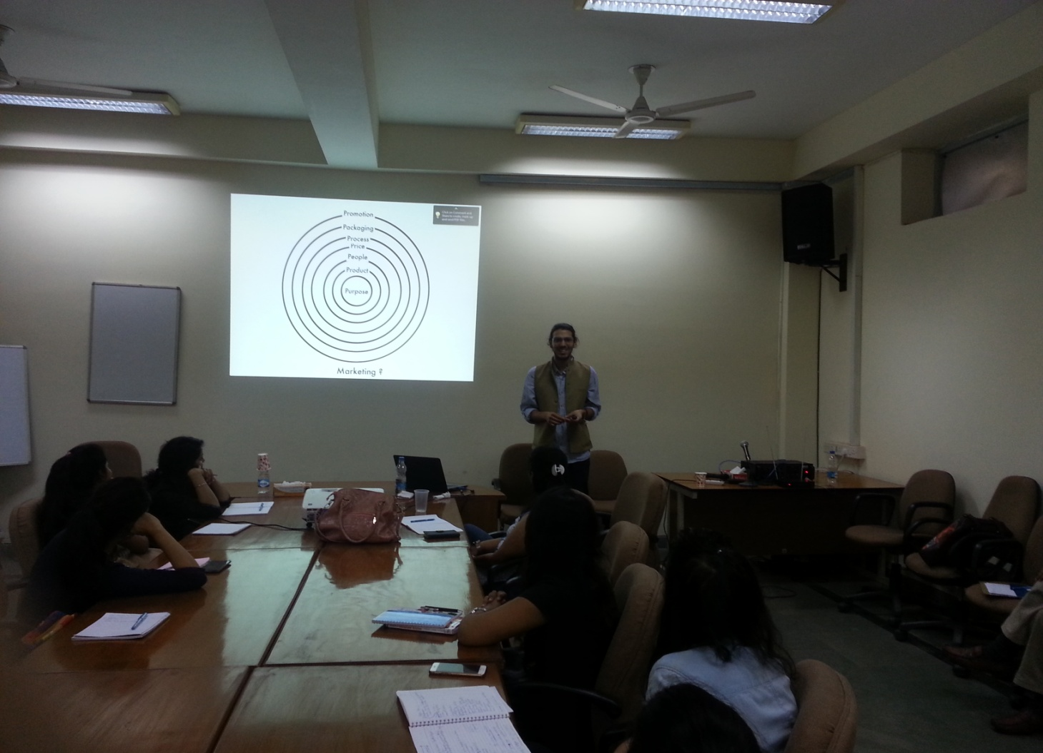

Speaker: Asome Dutta Baruah and Onkar Khullar
Asomee did her schooling at the Loreto Convent School, Shillong and then went to
Mount Carmel College, Bangalore and Indra Prastha College, New Delhi from where
she completed her BA in English. She finished her post graduation studies in Mass
Communication from the A. J. Kidwai Mass Communication Research Centre
(MCRC) under Jamia Milia Islamia University in New Delhi in the year 1989. She is
the first Assamese woman to have done her PG in mass communication and was
honored by then Chief Minister, Assam for this feat.

Onkar Khullar, Founder CEO of I-Impact India a unique CSR consulting firm. He is currently the Managing Partner of Impact India Partners. He is also the Managing partner of Presentation Ink. He has won various awards during School, College and after his college for his Business Plan/Presentations.
Key Themes:
- There are lots and lots of challenges in the journey of entrepreneurship, so an entrepreneur must have the passion to overcome that.
- Women entrepreneurs have to prove themselves at every point of life.
- The passion of helping others should be inherent.
- Always be prepared for the rapid changes that may happen in near future.
- Understanding different stages, time period and growth of the business.
- Understanding of own product or service and finding the USP (unique selling proposition) of it to convince the customers.
- Using different techniques, according to the customers, of marketing and selling the product.
Session 3: Success Story
Objective:
Speaker: Renuka Dudeja
Key Themes:

DAY 3 – THURSDAY – 13 OCTOBER, 2016

Session 1: Industry Understanding
Objective: To understand the industry to get competitive edge and learning about various methodologies which help to do competition research and industry analysis
Speaker: Anshumali Saxena
Key Themes:
- Industry is a group of firms producing a similar product or service, such as soft drinks or financial services.
- While doing Industry analysis there are six forces that need to be assessed, threat of new entrants, rivalry among existing firms, threat of substitute products, bargaining power of buyers, bargaining power of suppliers and relative power of other stakeholders.
- So while producing your product must keep in mind its gross margin, market available for product, its competitors. To deal with all such things always try to bring innovation to your product and add some different element, unique and new services to it so as to make your products production successful.
- We must always work on opportunity analysis, market segmentation and market targeting to decide which industry to be a part of and what market segment to target.
- A market consist of prospective buyers willing and able to purchase the existing or potential offering of an organisation so focus on buyers, their effective demand or as ‘offering’ rather than product or service and market share.
- Market segmentation is also very important. It will help in the identification for opportunities for new product development, help in designing marketing programs most effective for reaching homogenous groups of buyers and improves allocation of marketing resources.

Session 2: Societal Empowerment & Social Innovation
Objective:
Speaker: Anchal Bhatia
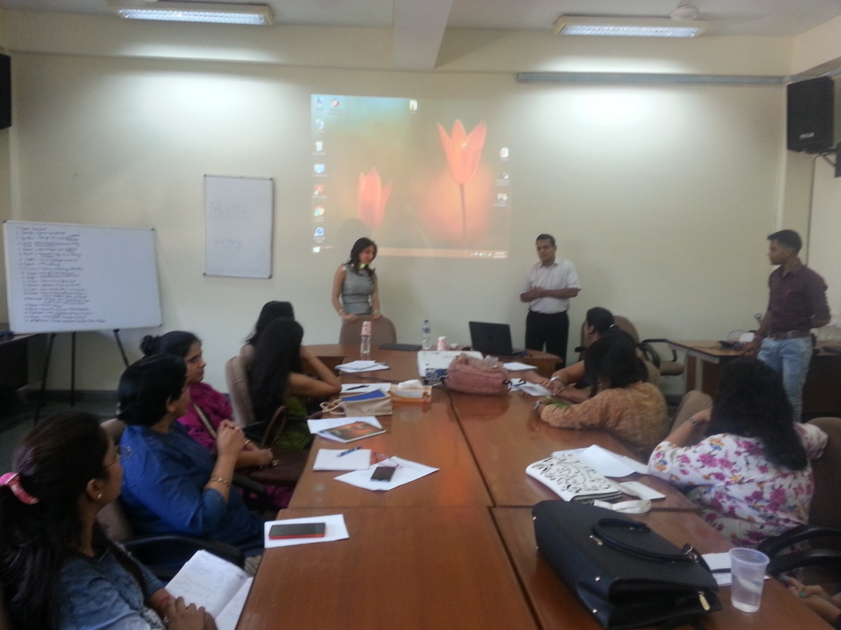
Aanchal Bhatia, is an entrepreneur, philanthropist,and patient advocate, whose new book “YourDoctor is not God” teaches people how to becomethe CEO of their own health and use consciousliving as a tool to enrich their health and lives, bothholistically and naturally. Aanchal Bhatia is a seasoned business leader with
12+ years of experience & is currently the President and Chief Clinical Psychologist at Texas Medical Concierge, Managing Trustee at Breathe Easy India and Director of Uttam group of Companies

Key Themes:

Session 3: Customer Understanding
Objective: Understand the need of Customer journey ,touchpoints ,expectation , approaches and why they are important in making a business successful .
Speaker: Nancy Juneja
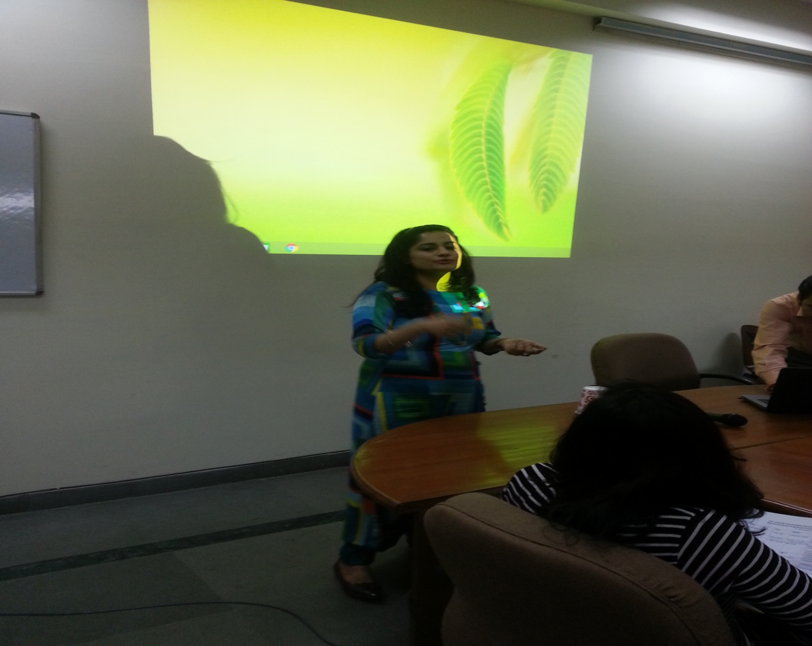

Key Themes:
- With the way business is done changing , The total value proposition provided to a customer has also seen a sea change in last one decade .
- Today Customer is the king and In order to attract new and retain existing customer , It is very important to provide maximum value
- The science and art of managing all interactions with customer across all touch points in order to maximize the value provided to the customer is called as Customer Experience Management.
- To understand Customer’s expectations better ,we must live the customer journey.
- Customer interacts with organizations on journeys that cut across individual touchpoints.
- Customer journey consists of identifying your customer, mapping their current experience and finding what change can bring WOW factor in their experience and brings the customer back to you.
- To live a customer journey ,you should understand the life cycle of of a customer while you do business with them and most importantly how you can converge to positive customer experience .
- 57% of customer with single negative experience don't do business again with that vendor.
- The Organization has to bring differentiating factor in their service along with retaining him with loyalty by generating emotions.
- Companies who excel in delivering customer experience display six hallmarks :
  - Define clear compelling value
  - Understand the journey matters
  - Continuously innovate
  - Use Journeys to reinforce front line cultures
  - Optimize operational process
  - Use Journeys to define metrics and governance system

DAY 4 - FRIDAY – 14 OCTOBER, 2016

Session 1: Innovation strategies for competitive advantage
Objective: Entrepreneurial individuals enable tomorrow's value creation by exploring for it today; having ideas , turning ideas into marketable insights and seeking ways to meet opportunities.
Speaker: Kamna Hazrati
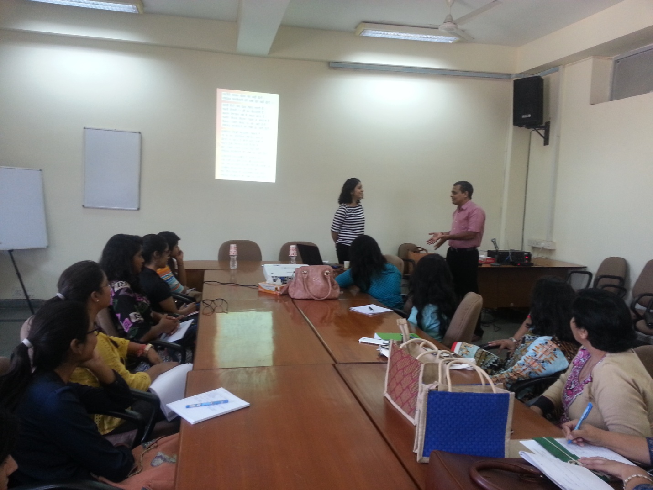

Key Themes:
- Innovation is the implementation of new ideas at the individual, group or organizational level.
- Innovation is planned and predictable- technology is the driving force of innovation success -big projects will develop better innovation than smaller ones.
- Understanding type of innovation is of strategic importance when deciding how to react to innovation, whether someone else introduced it before or you plan to introduce in market.
- The diffusion of innovation curve is useful to remember that trying to quickly and massively convince mass of a new controversial idea is useless.
- Creativity is the development of ideas about products, practices, services or procedures that are novel and potentially useful to the organisation.
Session 2: Successfully bringing Innovations to market
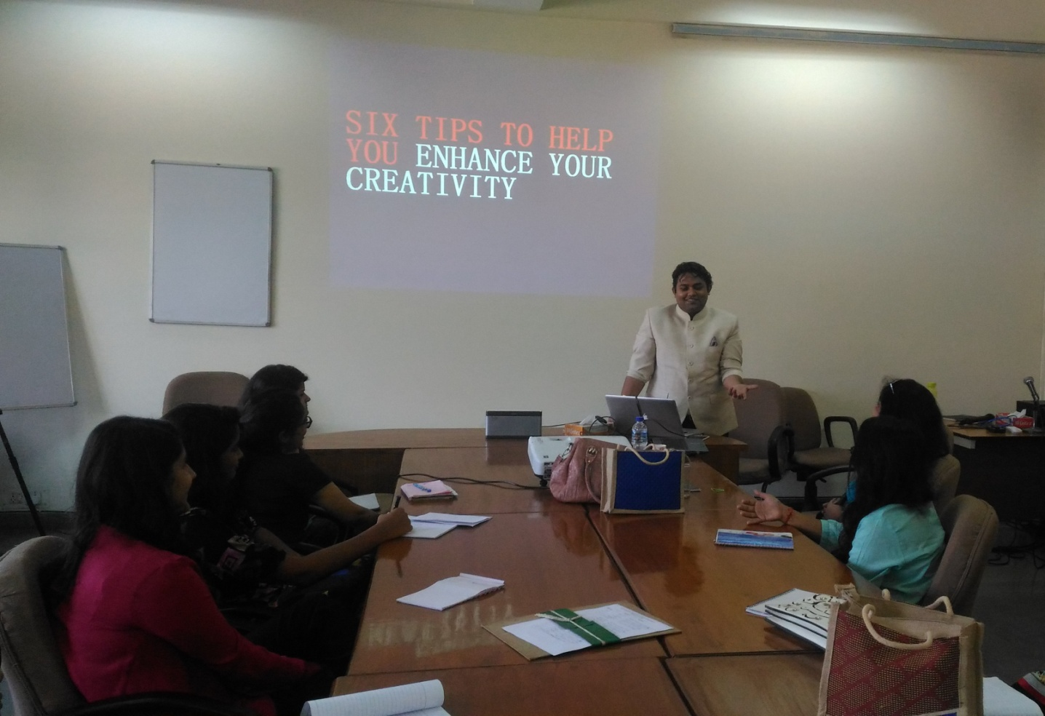

Objective: Successfully bringing Innovations to Market
Speaker: Thaldev
Key Themes:
- “Creative people pay attention to their world, see things differently, challenge assumptions, take risks, are not afraid to fail, and strive to generate multiple solutions to problems. They are passionate about creativity and seek opportunities to innovate. “
- Doing something new or else, something old in a new way is very critical
- to the success of anything.
- The intricacies of implementing new ideas that creates value.
- Illustration of this idea through the very powerful and popular
- Diesel campaign which revolutionize our opinion of ‘smart vs stupid’
- Highlight the importance of seeing things from a new perspective.
- Showcase 29 of the many reasons to be a creative person.
- Stress more on the idea of the need of creativity for innovation
- Exhibit these ideas through Redrebs, his own entrepreneurial venture.
- Encourage to find one’s own passion and pursue it.

Session 3: Success Story
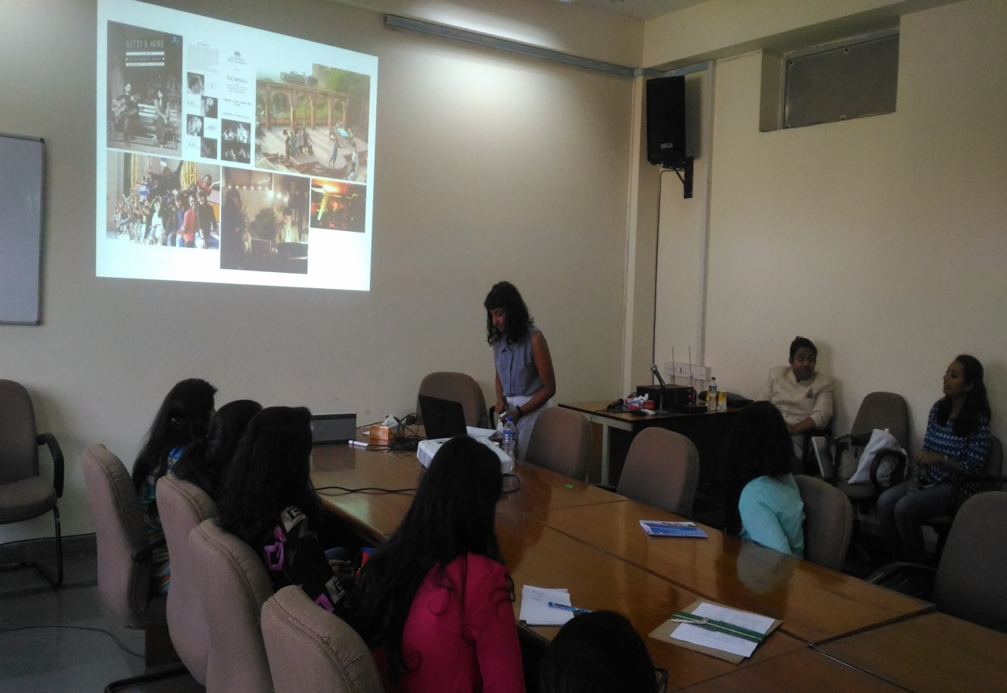

Objective: Running a socially responsible creative practise
Speaker: Aditi Veena
Key Themes:
- Life is self discovery, we all need to understand who we are and what we do i.e who how what and how much is enough.
- The two most important aspects of running a business should be innovation i.e. the process of innovating a new method or idea and ethics i.e moral principles that govern a person’s behaviour when conducting an activity
- The new way of looking at goals should be less work more play (for self). New =Bye to boredom (for work)
And think and think small for the planet
- Routine, consistency,discipline,motivation, inspiration and leisure are extremely important in order to maintain a work life balance.
- Tree love is a community led project initiated by the Vasant Vihar Residents’ Welfare association; to conscientiously engage with, conserve and protect the existing urban forests in our residential neighbourhood. Today it has become a success with the help of the MCD, RWA,forest department and the Delhi government. It started with numbering, identifying tree species, the age of the tree and whether they are infected or not. A small initiative became a community program.
- She is working on setting up a facility for cultivating self sufficiency in order to enable students with low income to build economic stability increase social support systems. In order to provide them with skill development, health counselling arts and expression and food and nursery (enabling them to grow their own food all under one roof.

DAY 5 - SATURDAY – 15 OCTOBER, 2016

Session 1: The Internet As a Selling Platform
Objective: To understand how Intelligent Enterprises are created with the help of Internet and in-depth discussion about the tools used for digital marketing
Speaker: Anshumali Saxena

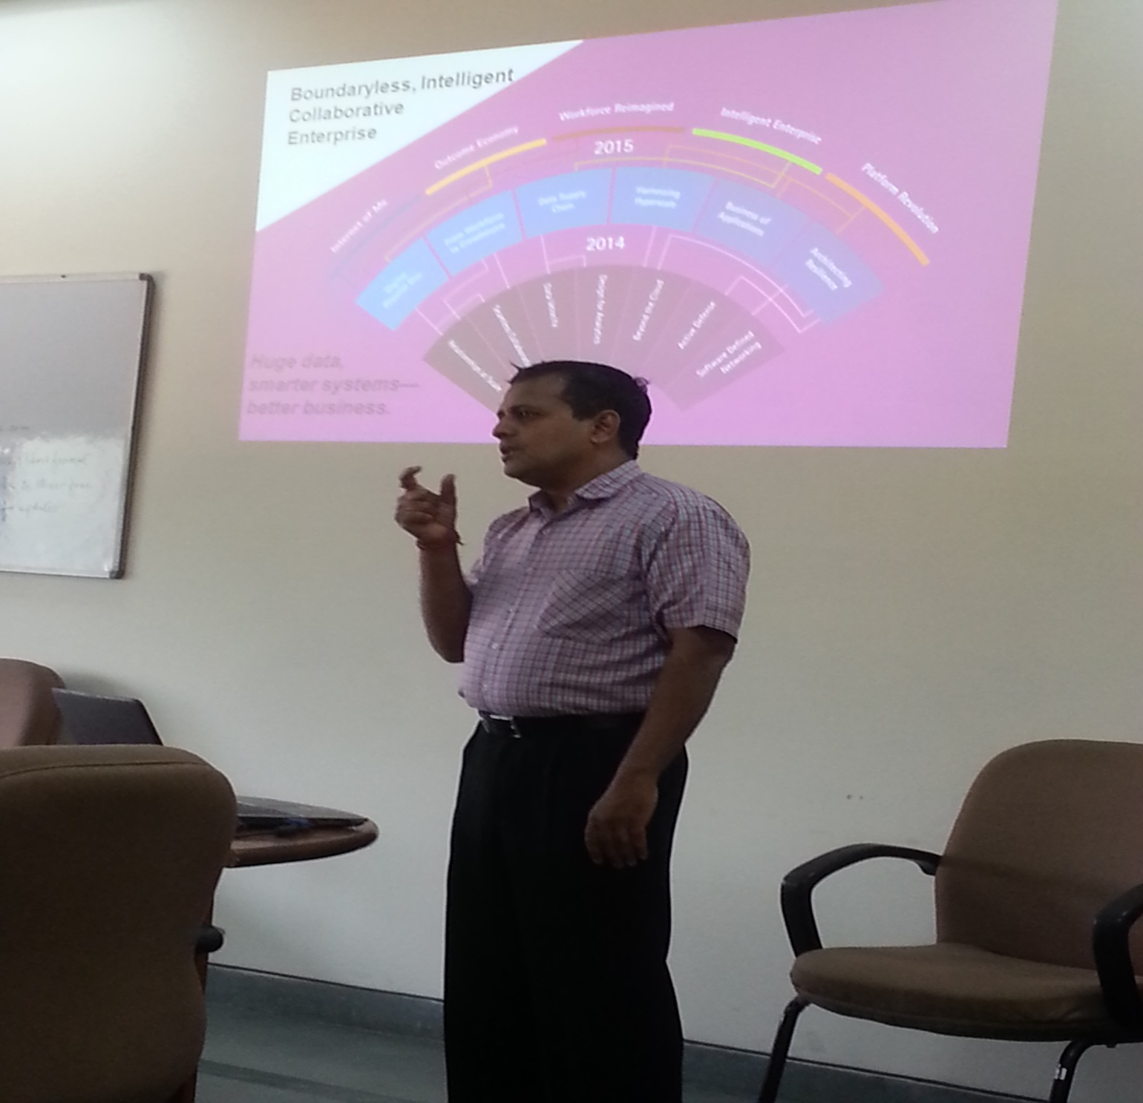

Key Themes:
- In today’s data driven world, there is huge amount of data which can be accessed and analysed. Businesses should make use of this data to make smart and intelligent decisions.
- Addressing 5 inescapable trends of businesses - Internet of Me, Outcome Economy, Platform Revolution, Intelligent Enterprise, Reimagined Workforce.
- Discussion on how numbers can drive actions. Communication can be made believable using data and statistics to support it. How to leverage data effectively & superior integrated intelligent marketing.

- In collaborative era, each individual who is associated with your business in any way will work as a brand evangelist and can make or break a brand by making use of Social Media platforms such as blogs, facebook, twitter, etc.
- Detailed discussion on customer journey from Awareness, Evaluation & Purchase to usage, repurchase and advocacy. How different communication tools are used at each step of user’s journey and what kind of content and stories are to be developed at each step.
- Era of digital Convergence - Aligning Marketing, Sales & Customer Service in Real time to give reality driven experience to the customers.

Session 2: Team Building
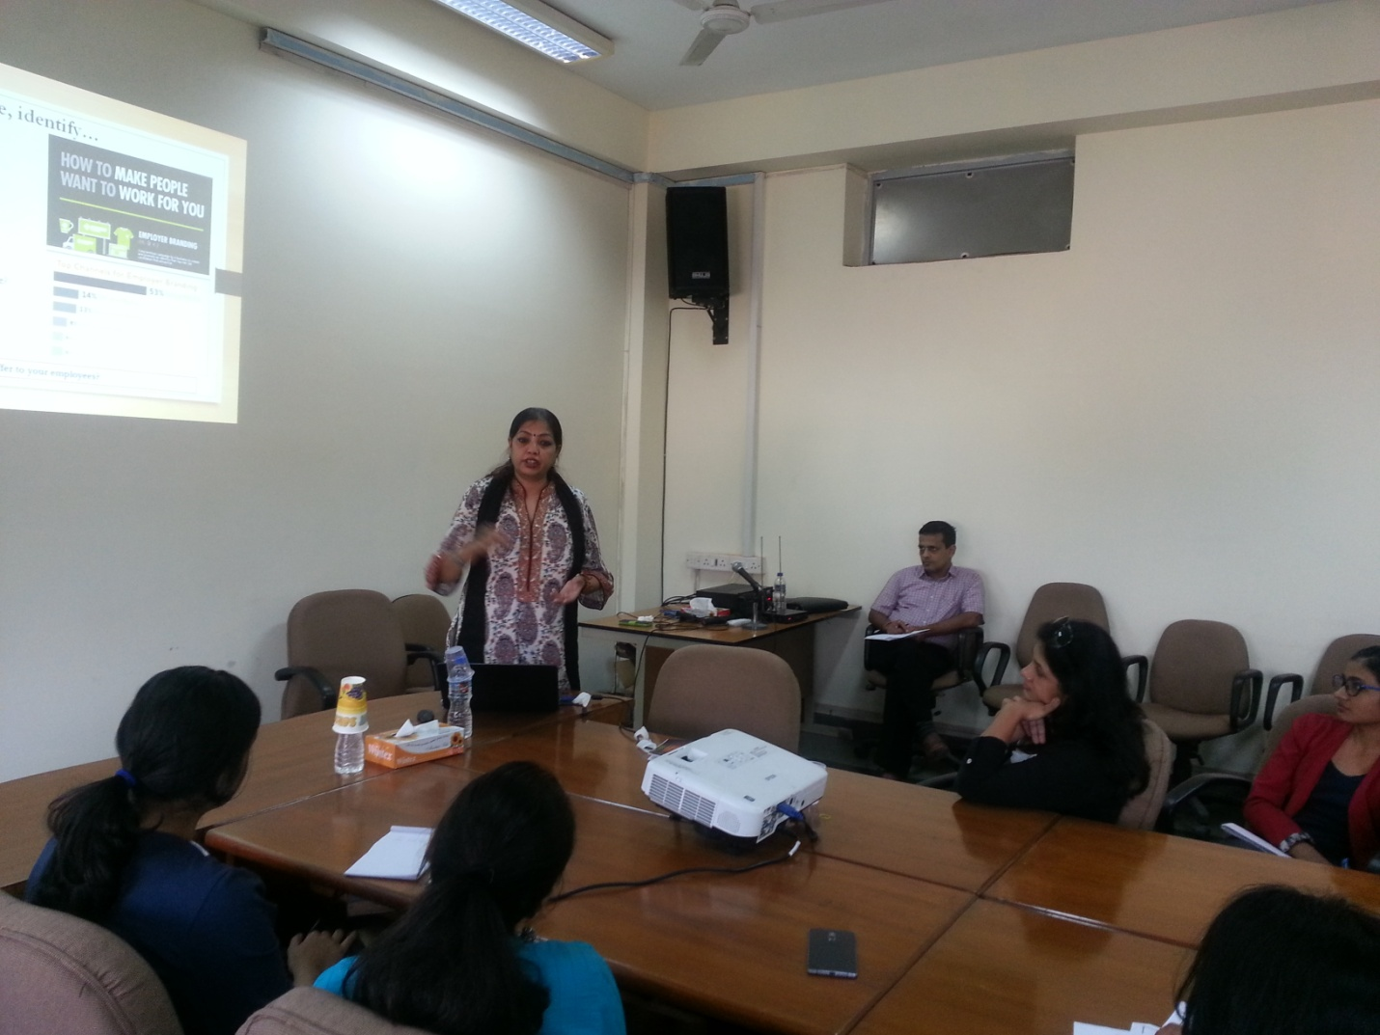

Objective: Importance of team in setting up the new venture, Attributes of an efficient team, ways to attract and retain the talent
Speaker: Monika Mudhgal
Key Themes:
- “A founder’s individual characteristics are important but what’s more important is that person’s ability to bring an efficient team with him / her.” Getting the right mix of people to complement and reinforce your business is essential.
- A great idea is the catalyst to gets things in motion, but at the end of the day, it’s the team who will ultimately determine the success, or failure, of the venture.
- Experience and Skills are required; however attitude is the foremost thing to be considered at the time of hiring an individual at any level.
- Appreciation and Motivation are the key enablers to make the people perform.
- Feed Forward, the new way to identify skill gaps and providing the support to the team members to overcome the shortcomings.
- “People are our brand Ambassadors” So businesses need to build up the culture that would not only attract the people but also retain them. And giving them due recognition and the fringe benefits (other than monetary) could be few mechanisms to achieve it.

DAY 6 - SUNDAY – 16 OCTOBER, 2016
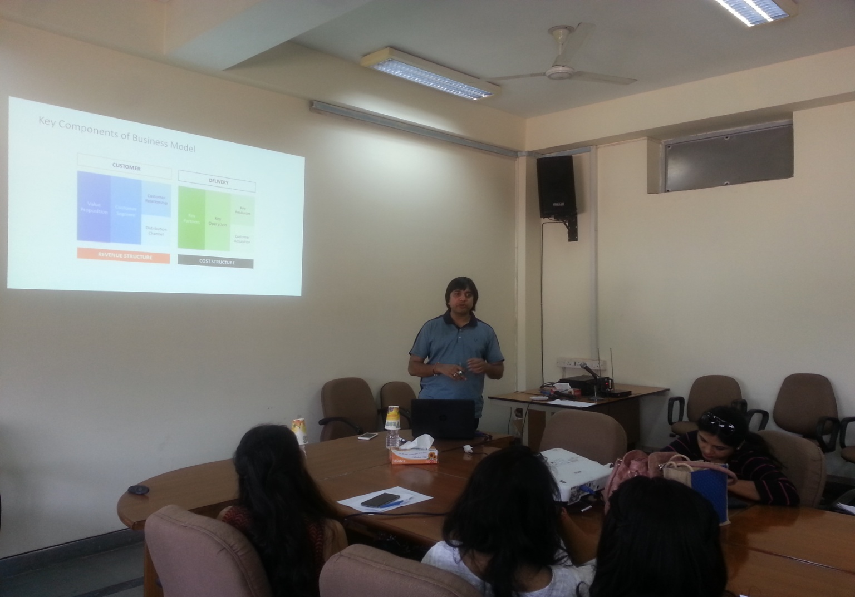
Session 1: Business Modelling
Objective:
Speaker: Amit Mohopatro
Amit Mohapatro is a co-founder and CTO at BlackBox IP; he also oversees the software development operations at Blackbox IP. He has over 15 years of software and technology-rich experience with global corporates like Infosys, Oracle, and IBM, and recently with CPA Global. Amit has managed projects and led teams in various stages of Technology lifecycle like conceptualizing, developing and implementing technology solutions. He has successfully managed business complexities and deployed multiple enterprise technology solutions in the US, Europe and India. He has extensive experience in implementing and managing Oracle in large companies. He leads R&D team at Blackbox,in developing advanced algorithms and insightful analytics. Amit is An electrical engineer and Master's in Business Administration.

Key Themes:
Every start-up should have clarity on their end Customer, They should understand
o ‘Who is their potential Customer’, keeping in mind the product or /& service they are dealing with;
o What is the value they are providing to the customer through their product which is in addition to the market competitors;
o What is the market segment they are targeting at ;
o What methodology or structure they have framed to reach out to the customer;
o What strategy they have framed to hold on their customers;
· An On-line Start-up should have a clear Policy on their Revenue generation policy. It is extremely essential, else they would end spending a huge amount in capturing their customer base mindlessly resulting in huge losses. A few model they can frame their company on are :
o Fremium Model
o Subscription Model
o Advertisement Model
o Virtual Good Model
o Be in the market model ( Capturing a large customer base)
· Small business should lay out their budget and try that they do not overshoot or overshoot in their expenditure. An insight about fixed & variable cost should be clear to the entrepreneur vis-à-vis the capital available for the business.
· The Organizational Structure should be laid keeping in mind the business preposition, whether it is targeting a service industry, retail sector, manufacturing sector, IT or sales/marketing sector. Team selection, evaluating their competencies, number to be hired are few of the crucial decisions which tantamount to the success of the business model. A thumb rule is of not trying to fit circles into squares.
· The team should do their SWOT analysis, evaluate their strength & make sure they build on them and should not outsource the areas in which are excelling & competent in initial period until they have reached a break-even point.

Session 2: Securing Finances
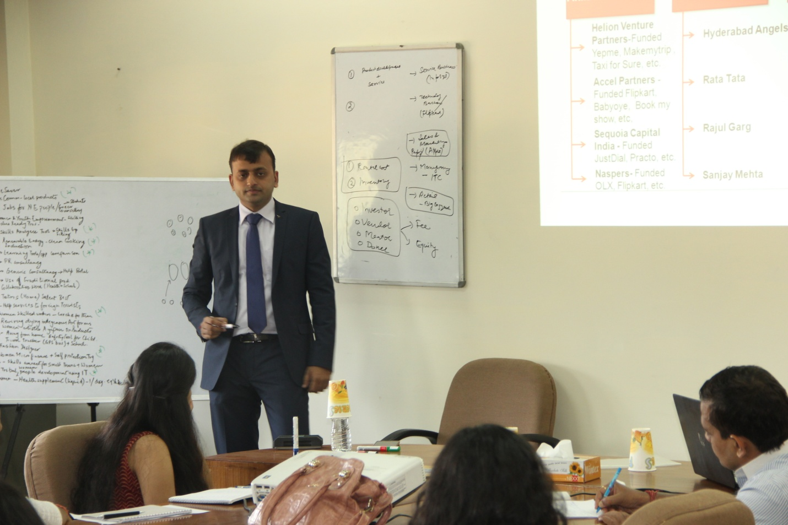

Objective:
Speaker: Balwan Bansal
Acupro Consulting, Co-Founder & Director
Key Themes:

Skill Enhancement Program for Prospective Women Entrepreneurs

ARC Building, University of Delhi I 11-16 October, 2016

CIC- Centre for Science Education and Communication
Academic Research Centre Building,
2nd floor, Patel Marg, University of Delhi, Delhi- 110007

e-mail: dir.csec@gmail.com
Phone: 011 –2766 6599, fax: 2766 7082

